Final PortfolioGianna Scibettahorizontal line

short line

Johnson & Johnson

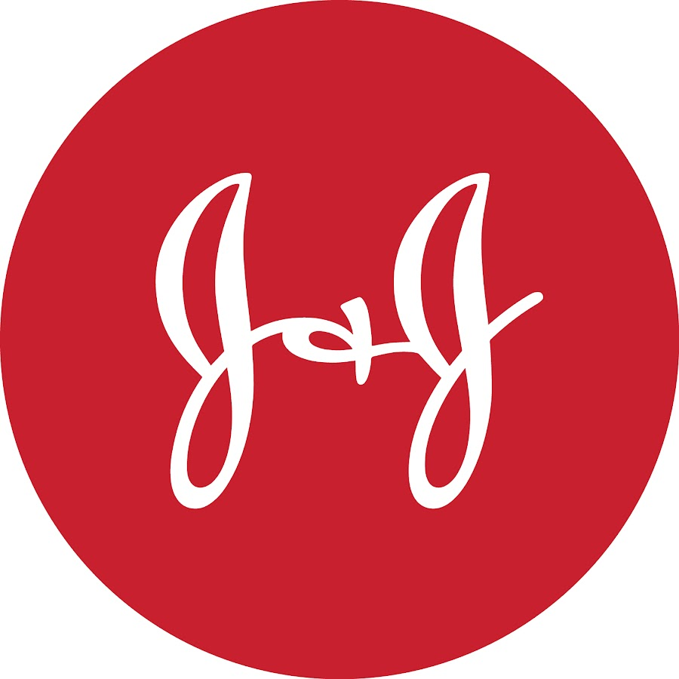

# Gianna Scibetta

<https://gigiscibetta.wixsite.com/my-site>

[gigiscibetta@gmail.com](mailto:gigiscibetta@gmail.com)

702-283-1351

Dear reader,

Welcome!

As a student at DePaul University studying public relations and advertising, I am lucky to learn amazing techniques and tips from some of the best in this profession. I have learned that the best way to become the best writer that I can be, is through practice and experience. I have never been so excited and dedicated to continue to learn how to be better at my projects and writing.

What you will find inside is my compiled work as I have taken on a Johnson & Johnson Co. as a “client” during my Writing for Public Relations Class. These pieces range from press releases, to media kits and much more. Johnson & Johnson Co. was an amazing company to learn from over these months of work. As the company has truly been one I have looked up to during the COVID-19 Pandemic.

Thank you so much for taking the time to check out my portfolio. Please do not hesitate to reach out with any questions or comments!

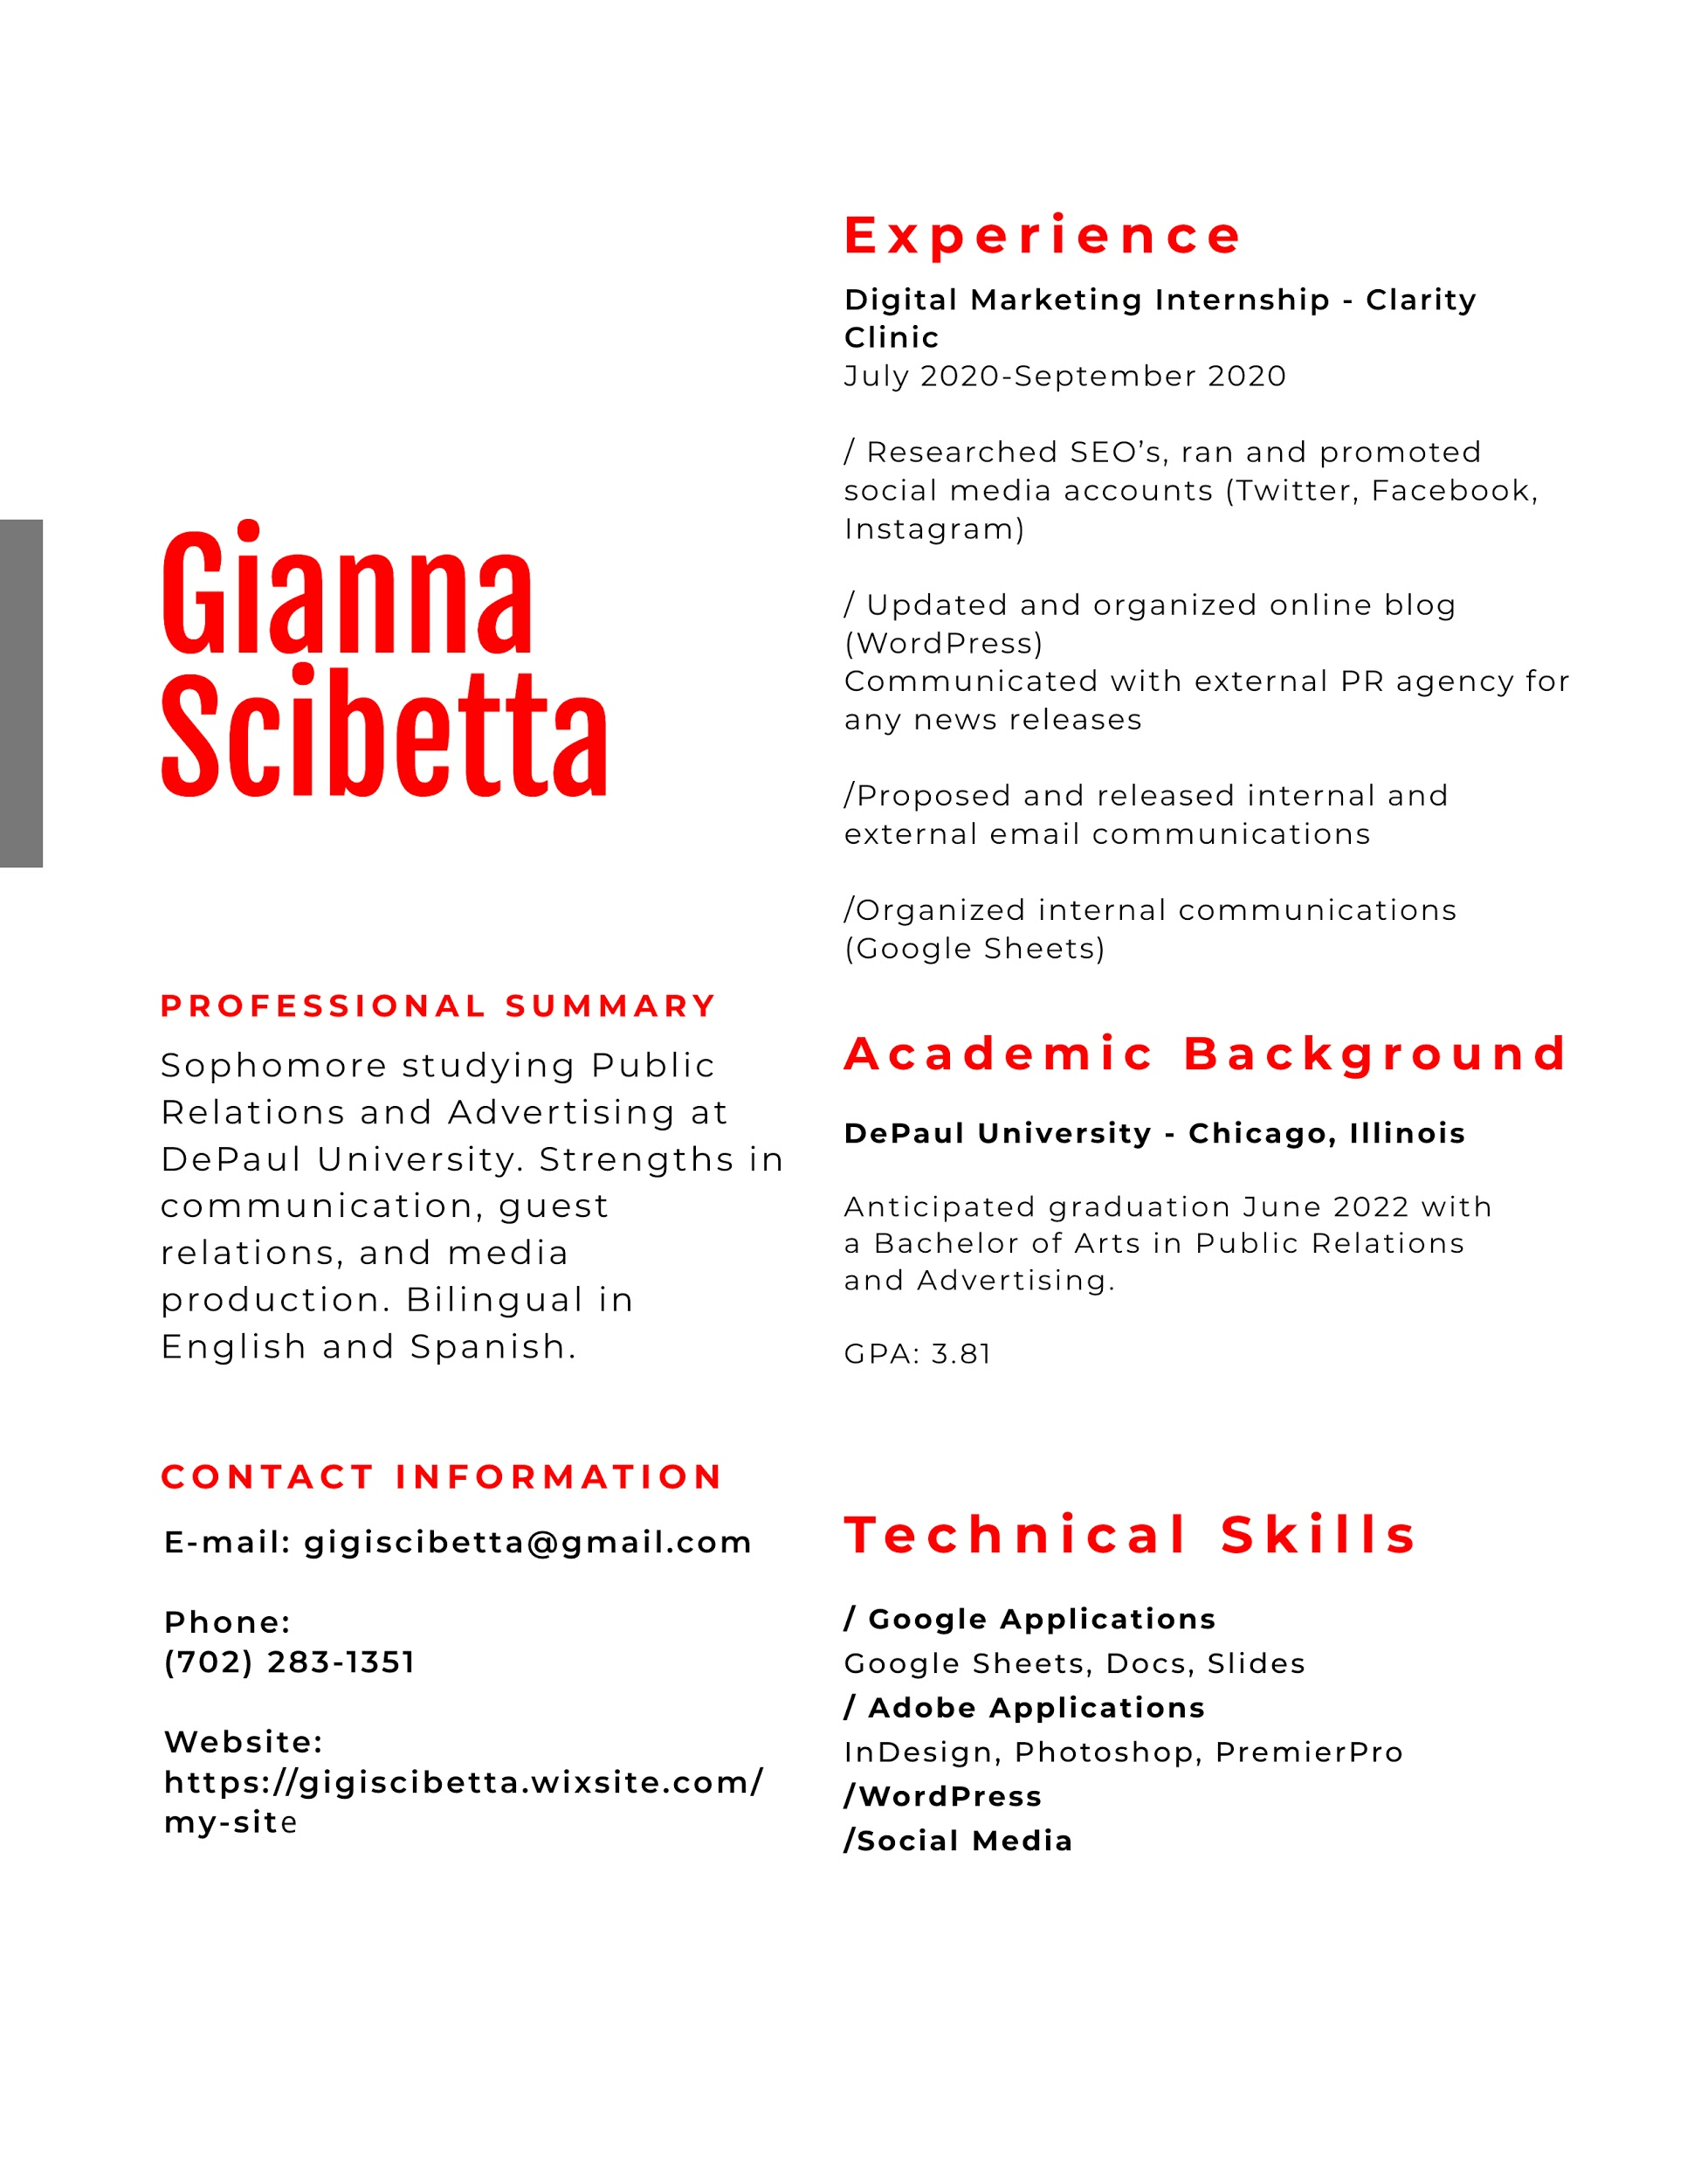

# Press Release

**For Immediate Release**

**Johnson & Johnson narrows in on COVID-19 vaccine to be released to the public**

Chicago – Jan. 26, 2021- As the world reaches nearly a year since the World Health Organization (WHO) labeled the Coronavirus “COVID-19” a global pandemic, the public waits anxiously for a glimmer of hope.

Johnson & Johnson company has been with the public each step of the way, from providing the frontline workers with adequate PPE, to making sure the shelves of stores were stocked with all necessary household cleaning items. It has been Johnson & Johnson's top priority to see what else the company can do to support the public in order to reach an end of this pandemic.

Johnson & Johnson has been working tirelessly to develop a COVID-19 vaccine. The scientists at Johnson & Johnson have been using their knowledge they have gained from previous studies done on treatments for HIV and Ebola.

“Johnson & Johnson has wanted to ensure that the public knows that this company has their best interests at heart,” CEO Alex Gorsky, “we understand how this global pandemic has impacted the general public in tremendous ways, and we here at Johnson & Johnson want nothing more to move on from this.”

The company has the safety and well-being of patients at the front of their minds and are making sure that the development of the COVID-19 vaccine is safe and effective. In the last rounds of the trials with over 75,000 participants, the company awaits approval from the Federal Drug Administration (FDA).

# Pitch Letter

**Email Media Pitch**

Subj: **Wait time and line for COVID-19 Vaccines just got shorter with Johnson & Johnson one-dose shot.**

Johnson & Johnson has stood with the public throughout the COVID-19 outbreak, from increasing manufacturing of household goods and cleaning products, to providing PPE for our frontline workers. As Johnson & Johnson navigated through the pandemic with the public, we understood it would be our duty and commitment to get Janssen Pharmaceutical Companies of Johnson & Johnson on the road to developing another COVID-19 Vaccine.

As early as March 2020, the researchers and scientists of Janssen Pharmaceutical Companies of Johnson & Johnson started a lead investigation into the development of a vaccine. As the researchers of Janssen Pharmaceutical Companies enter Phase 3 ENSEMBLE of the development of the vaccine, it was announced that the company would be approved by the Federal Drug Administration (FDA) for Emergency Use Authorization (EUA).

What makes the Johnson & Johnson COVID-19 vaccine different from those already being administered, is that it is a one-dose shot. Unlike the other vaccines that require patients to return for a second dose, the single-dose shot will make administering the shots quicker and faster to the public.

The vaccine will start production in partnership with Merck, and Johnson & Johnson promises that 100 million single-dose vaccines will be delivered to the U.S. by the end of the first half of 2021.

**Some fast facts about the approval of the Johnson & Johnson COVID-19 vaccine:**

* The vaccine is a single dose vaccine and will be administered in only one visit.
* Johnson & Johnson promises delivery of 100 million doses to the U.S. by June 2021.
* The vaccine was found to be 85% effective in preventing illness or hospitalization related to COVID-19 28 days after vaccination.

If you have and questions or would like to hear more about Johnson & Johnson’s efforts to slow the spread of COVID-19 and manufacturing of a historical vaccination, please feel free to contact me through email at gigiscibetta@gmail.com or call me at 702-283-1351.

Best,

Gianna Scibetta

PR Associate

Johnson & Johnson

# Fact Sheet

**Company Name:** Johnson & Johnson Co.

**Headquarters:** New Brunswick, New Jersey

**Description:**

Johnson & Johnson is an American based- Multinational corporation. Founded in 1886, Johnson & Johnson is one of the most notable and recognizable names in packaged goods, pharmaceutical, and medical devices producers in the world.

**Notable Names:**

* Alex Gorsky, Chief Executive Officer (CEO) - April 26, 2012

**FAST FACTS:**

* Johnson & Johnson’s consumer brands are often the first and most personal experience people have with our company. Our baby care, beauty, oral care, self-care, women’s health and wound care brands have been trusted by consumers and healthcare professionals for more than 100 years.
* Our mission is to make diversity & inclusion our way of doing business. We will advance our culture of belonging where open hearts and minds combine to unleash the potential of the brilliant mix of people, in every corner of Johnson & Johnson.
* J&J consists of more than 250 subsidiaries.
* J&J is one of the world's largest corporate donors, Johnson & Johnson gave a little more than $157 million to charity in 2013, a 20% increase from the previous year.
* Our finished products are only as safe as the raw materials we use to make them. That’s why we only work with suppliers that meet our exacting safety standards. Our screening process enables us to know with certainty the purity of every raw material.
* Johnson & Johnson has been committed to caring for people since its founding in 1886. But it was in 1943 that those founding values were put to paper, when the guiding manual of the company, Our Credo, was first drafted.

# Intranet Story

To our valued employees,

The changing times with the COVID-19 we understand your confusion and concerns about returning to work. At Johnson & Johnson our number priority is ensuring that our employees have a safe and comfortable work environment.

During the global pandemic, Johnson & Johnson has remained vital to the health and safety of not only frontline workers but the general public, and we couldn’t have done it without everyone in this company. We thank everyone for their continued efforts to promote the Johnson & Johnson Credo that; “Our Credo challenges us to put the needs and well-being of the people we serve first.” Yet again, was done with every single one of you.

As we move forward in figuring out ways to return to the office, we understand that there are many questions to be asked and answered and we are trying our best in order to do this. We have decided that some segments of the company that hold office-based positions can reduce social contact and continue working from home.

Those who work in research laboratories and facilities may have to return in person, under COVID-19 social distancing practices. Those who have to return to in-person work are eligible for the Johnson & Johnson one-time award of $1,000.

We also understand that due to personal circumstances, some employees may not be able to return to in-person working conditions, and if you are one of these people, we encourage you to look into receiving paid-time leave. We have encouraged managers and supervisors to be flexible with scheduling as much as possible.

Over time we as a whole at Johnson & Johnson will be learning together on our return back to the office. Credo-based commitments to care for employees, their families and the communities in which they live and work during this global health crisis.

If you have any questions or concerns, please do not hesitate to reach out to your Human Resources manager.

Once again, thank you for being a part of this Johnson & Johnson family.

# Key Messages and Q&A

**Three Key Messages Johnson & Johnson:**

1. Johnson & Johnson keeps health and for humanity at the utmost importance.
2. J&J has cut our carbon footprint by 15% in the past 10 years in order to ensure a better climate for our future.
3. Johnson & Johnsons mission is to make diversity and inclusivity the only way of going about our business.

**5 Questions and Answers:**

**Q: How do you as a company plan to have a diverse workforce?**

A: On the basis of three pillars: Advance Our Culture of Inclusion and Innovation, Build a Diverse Workforce for the Future, and Enhance Business Results and Reputation.

**Q: What makes the Johnson & Johnson COVID-19 vaccine different from the others?**

A: The J&J COVID-19 Vaccine can be administered in a single-dose, unlike those that are already being administered such as Moderna or Pfizer.

**Q: What is “Our Credo?” and what does it mean for the company?**

A: Our Credo is our values that guide our decision making as a business. Our Credo challenges us to put the needs and well-being of the people we serve first.

**Q: What are some of the responses for those who are surprised or shocked to see J&J is making a COVID-19 vaccine?**

A: We would let them know that we have worked for 20 years on the advancement in medicines to end HIV and TB, and are no strangers to understanding the importance of mass-vaccination in order to help those in need and in risk of being infected.

**Q: What are some of the efforts that Johnson & Johnson made at the beginning of the COVID-19 pandemic?**

A: Johnson & Johnson has supported frontline workers since the beginning of the pandemic, supplying them with adequate PPE. As well as matching donations to those who are struggling with the impact of the financial crisis surrounding the global pandemic.

# Sample Social Posts

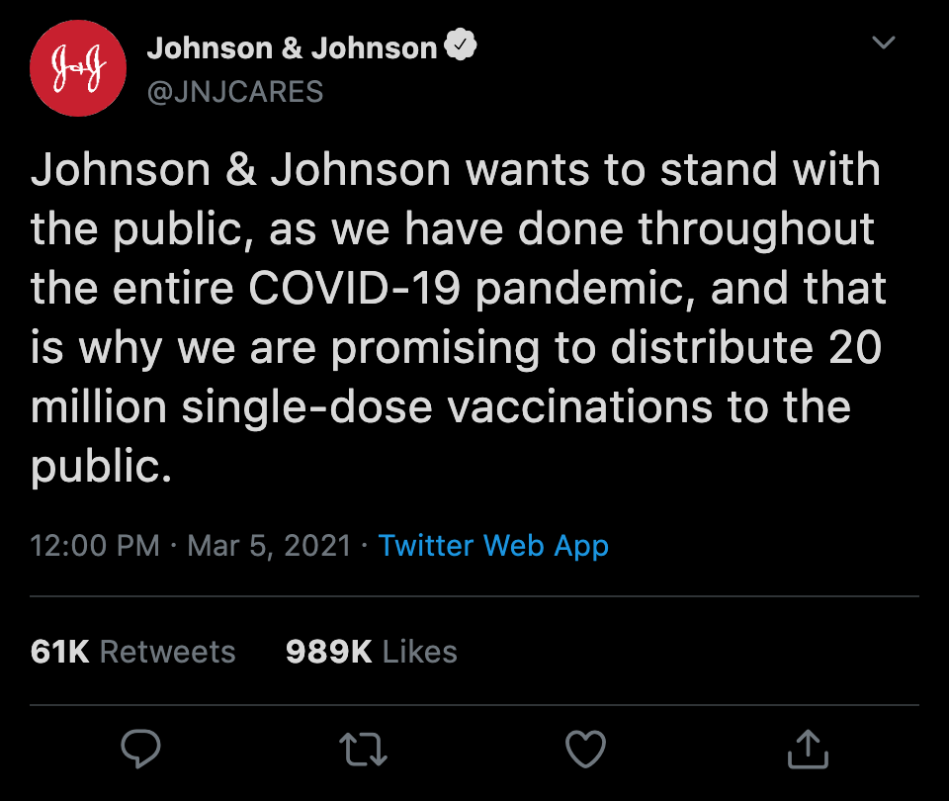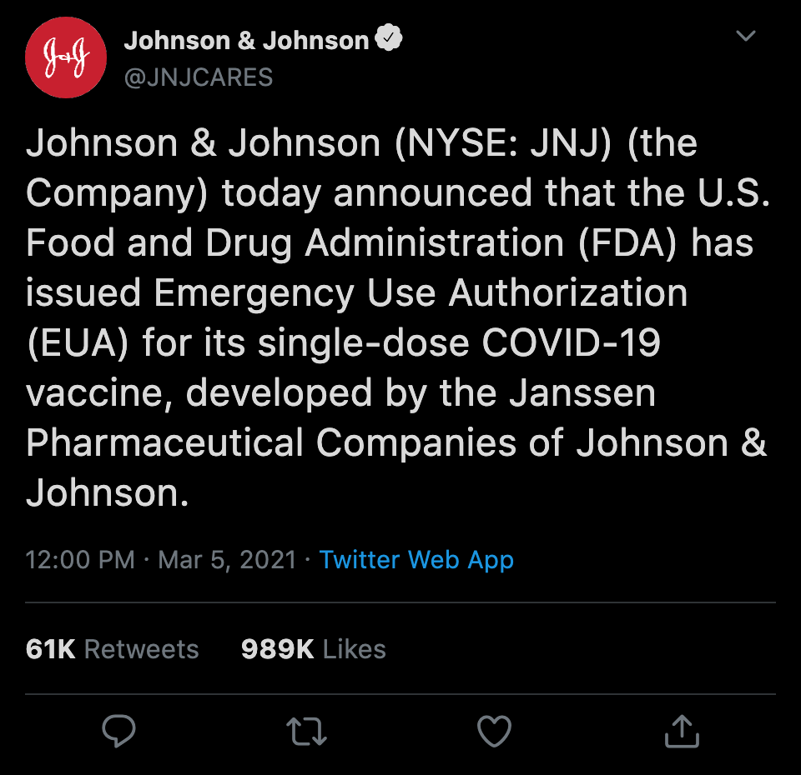

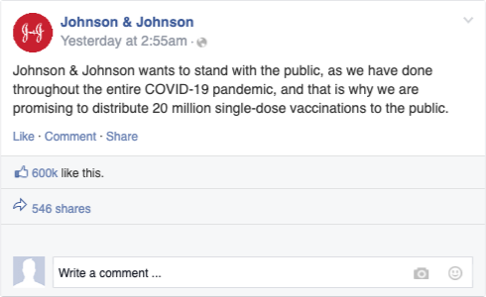

# 

## Media Audit

Johnson & Johnson Co. has remained one of the largest household names in the world. With a $21.8 Billion dollar revenue each year, as well as being one of the most popular companies to be a shareholder in the NYSE. Johnson & Johnson Co. has done an amazing job remaining a notable name overtime, but may be able to increase their overall online presence.

With the company maintaining multiple segments in production of not only health related products, but everyday use products, their ability to connect with their younger consumers may benefit them. Their online media presence, such as Youtube videos and social media posts, may allow their products to be reviewed and trusted by young consumers. This will allow the brand to create a younger image and maintain their strong grasps on continued consumers.

|  |  |
| --- | --- |
| Strengths | Weaknesses |
| * Maintains a clean public image * Continued support with press releases by large media outlets | * Lacks a more engaging online media presence * Social Media accounts rarely updated with releases of new products |
| Opportunity | Threat |
| * Remain a trusted company in households * Continued growth in the stock market | * May lose grasp on overall Credo * Can be seen as out-of-touch with company ideals |